**Homily – Easter Sunday:**

**The Power of the Resurrection**

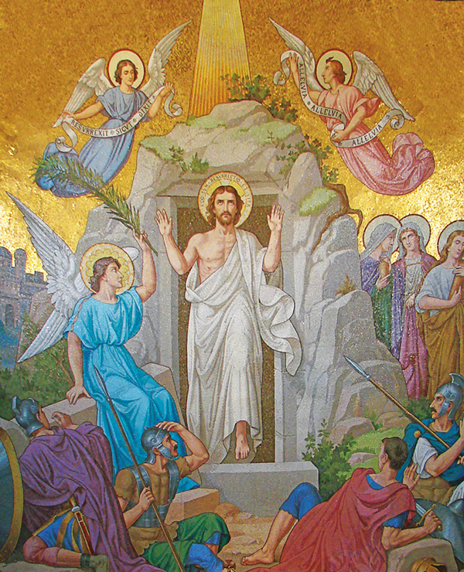

Dear brothers and sisters in Christ,

There was once a young boy who prided himself on being an intelligent, rational thinker. He believed in logic, in facts, and in proof. One day, he came to his mother—a woman of deep and unwavering faith—and said, “Mama, I have some shocking news for you.”

Startled, she turned and asked, “What is this shocking news?”

“Mama,” he replied, “I read that scientists and archaeologists have found bones in a tomb, and they believe these are the bones of Jesus. So now you must stop believing in Jesus. You must stop saying that He is risen.”

The mother, who was cooking in the kitchen, didn’t even turn to look at him. Calmly, she said, “Perhaps God allowed some bones to be found in a tomb—not because they belong to Jesus—but to test whether you believe the Word of God or the word of man.”

**Brothers and sisters, today is a day to examine our faith.**

Let us go back to that dark day we call **Good Friday**. Jesus, our Lord, was crucified on the hill of Calvary. His followers were few—perhaps only a hundred remained faithful to Him. At the cross, we read in Scripture, only a small group stood by: His mother, a few women, and the beloved disciple.

And yet, more than 2,000 years later, over **2.3 billion people** across the world profess the name of Jesus. How did this happen?

How does a man who died with barely a handful of followers now have a global Church that spans every continent?

The answer is simple: **He rose from the dead**.

We do not follow a myth or a legend. Our faith is not built on a fable or a philosophy. Christianity is rooted in an **event**—the resurrection of Jesus Christ from the dead. The Gospels are not fairy tales beginning with “Once upon a time.” They are historical accounts written by those who saw, heard, and touched the Risen Lord.

Think of **St. Peter**—the one who denied Jesus three times. On Good Friday, he trembled before a servant girl. But after meeting the Risen Christ and receiving the Holy Spirit, Peter stood before crowds and proclaimed boldly:

"We are witnesses. We ate and drank with Him after He rose from the dead."

And St. Paul tells us in **1 Corinthians 15**:

"Christ died for our sins... He was buried… He was raised on the third day… and He appeared to Peter, to the Twelve, to more than 500 others… and finally, to me."

We do not believe in a dead God or a carved idol. **We believe in a living God—Jesus Christ—who conquered sin and death.**

**What does the Resurrection mean for us today?**

Let me offer **three simple implications** of this glorious truth:

**1. Jesus is who He claimed to be.**

He said, “I am the Way, the Truth, and the Life.”  
If He rose from the dead, then every word He spoke is true. He is not just a spiritual teacher or a moral leader—**He is the Messiah, the Son of God, the Savior of the world**.

The Gospels aren’t just biographies. If they were, they would end at chapter 19, when Jesus was buried. But the story continues, because **Jesus lives**.

**2. Our sins are forgiven.**

After the resurrection, when Jesus appeared to His disciples, His first word was **“Shalom”—Peace**.  
Why peace? Because through His death, He reconciled us to the Father. His sacrifice was accepted. As in the Old Testament, when fire came down to consume a worthy offering, now the Father raised Jesus as a sign of acceptance.

**Your sins are forgiven**, not because of your efforts, but because of what **He did**.

Are you burdened by guilt? Are you bound by sin? Come to the Risen Lord.  
He offers peace. He offers forgiveness.

**3. Salvation is offered to all—but must be accepted personally.**

Romans 10:9 says:

*“If you confess with your lips that Jesus is Lord and believe in your heart that God raised Him from the dead, you will be saved.”*

The gift is offered to the whole world, but each one must receive it.

Just as a vaccine sitting on a shelf won’t help you unless you take it, **salvation must be received by faith**. Confess Jesus as Lord. Believe in His resurrection. And you will be saved.

**Dear friends**, don’t be shaken by worldly philosophies or theories. The world has seen many thinkers, skeptics, and critics rise and fall. But the Word of God endures.

The Church has stood for 2,000 years because **this truth remains unchanged: Jesus Christ is risen from the dead.**

Let us rejoice today like the disciples who saw the Risen Lord. Let us move from despair to hope, from doubt to faith.

Let us pray:

Lord Jesus, we thank You for the victory of Easter.  
We believe that You died and rose again.  
Help us to trust not in the words of men, but in the eternal truth of Your Word.  
May we live not just for this world, but with our eyes fixed on heaven.  
Help us to experience the peace and joy of the Resurrection today and always.  
Amen.

**Alleluia! Christ is Risen!**  
**He is Risen Indeed. Alleluia!**